Netaji Subhas University of Technology, New Delhi

COCSC16 - DATA MINING PRACTICAL FILE

Amogh Garg – 2020UCO1688



**INDEX**

|  |  |
| --- | --- |
| **EXPERIMENT** | **AIM** |
| 1 | Exploring and getting started with WEKA |
| 2 | Implementing data cleaning, missing value handling and normalisation on WEKA |
| 3 | Implementing discretisation and decision tree on WEKA |
| 4 | Calculate the dissimilarity matrix |
| 5 | Implement regression (linear, logistic, any one) in python on any dataset. |
| 6 | Implement KNN classification in python on any dataset. |
| 7 | Implement OneR in python on any dataset. |
| 8 | Implement Decision Tree in python on any dataset. |
| 9 | Implement Apriori algorithm in python on any dataset. |
| 10 | Implement FP Growth algorithm in python on any dataset. |
| 11 | Implement Random Forest Classifier in python on any dataset. |

**EXPERIMENT-1**

**AIM:** Exploring and getting started with WEKA.

**STEPS AND OUTPUT:**

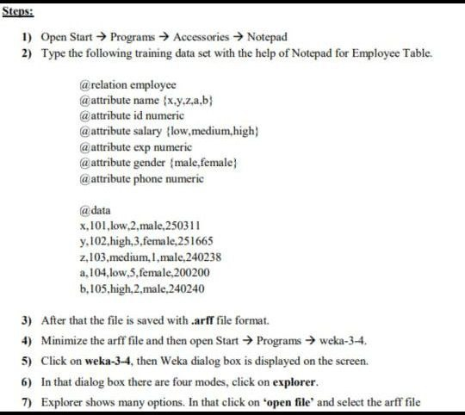

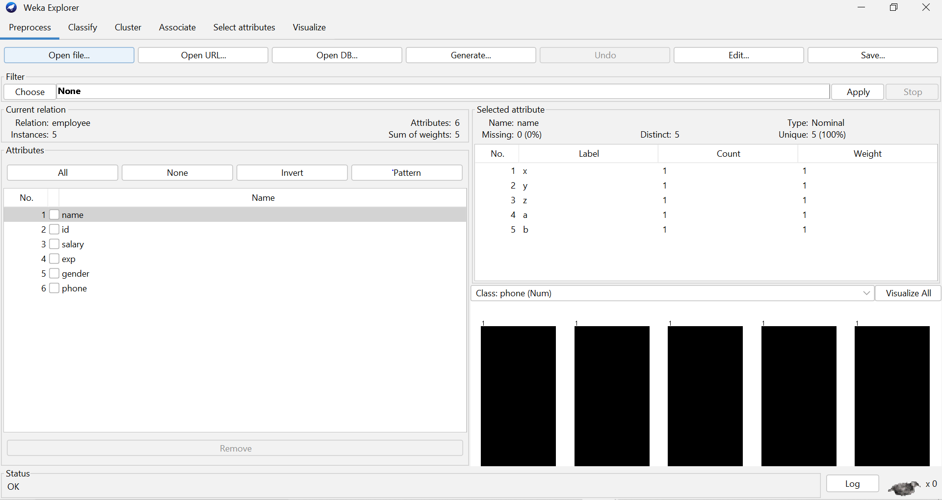

**EXPERIMENT-2**

**AIM:** Implement the following on WEKA using various filters:  
1. Data Cleaning  
2. Missing Values Handling  
3. Normalisation

**STEPS AND OUTPUT:**

1. Load the IRIS dataset on WEKA and open the “Pre-process” tab.

2. The attributes which are not useful can be removed by selecting the attribute and clicking on the “remove” option.

3. Click the “Choose” button for the filter and select “ReplaceMissingValues”, it us under unsupervised-> attribute-> ReplaceMissing-> Values and then select “Apply”.

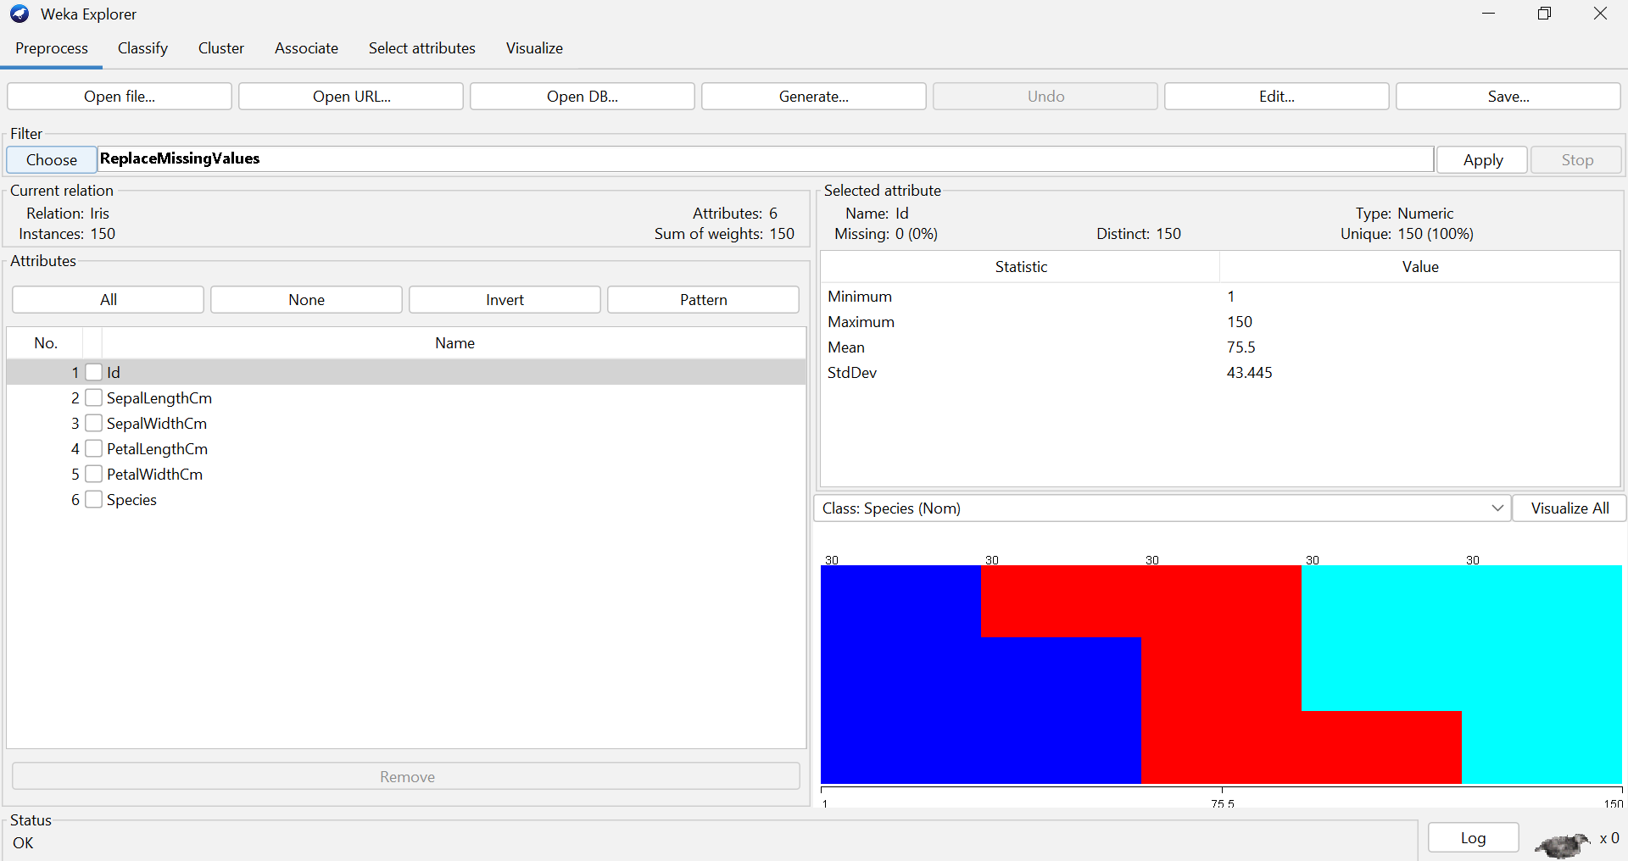



4. Click the “Choose” button for the filter and select “Normalise”, it us under unsupervised-> attribute-> Normalise and then select “Apply”.

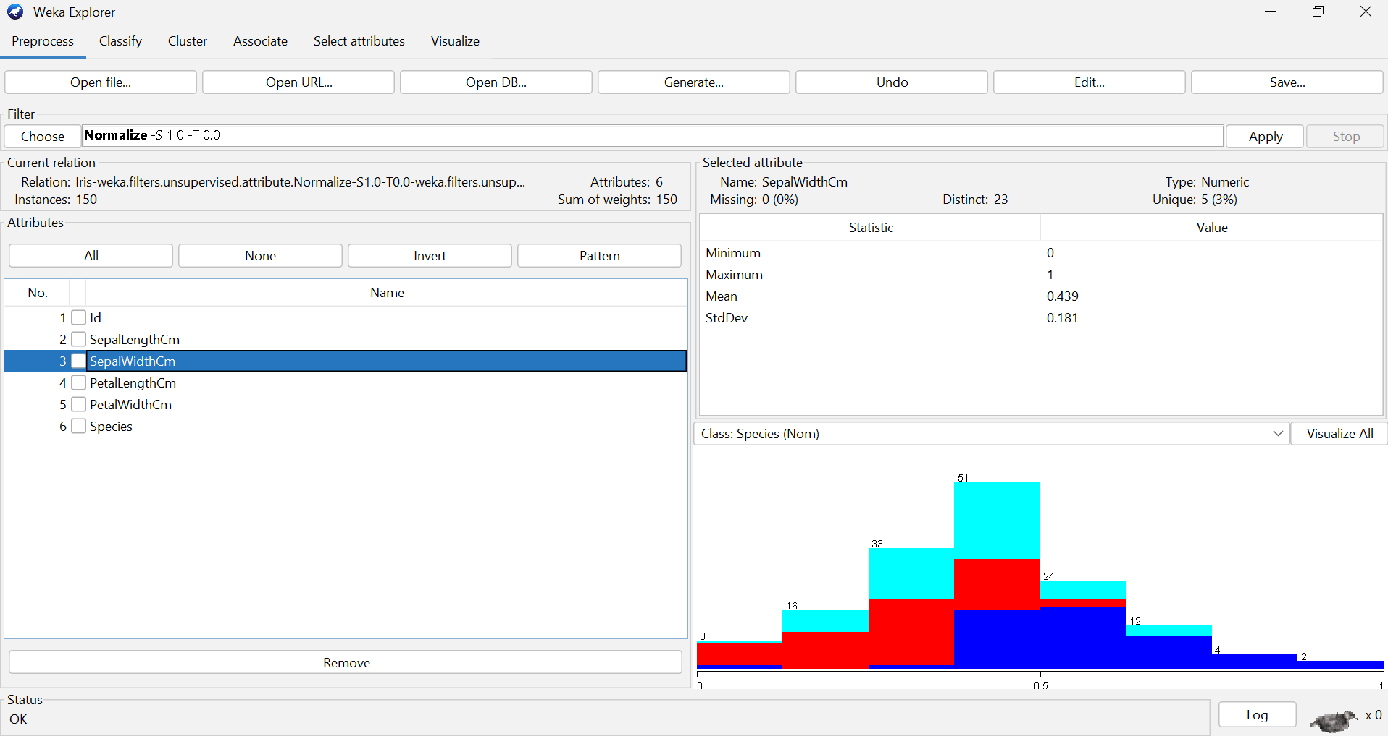



**EXPERIMENT-3**

**AIM:** On a dataset first do normalisation and then discretisation, then fit a decision tree model for classification.

**STEPS AND OUTPUT:**

1. Follow the steps of experiment-2 till normalisation on the IRIS dataset.
2. Click the “Choose” button for the filter and select “Discretise”, it us under unsupervised-> attribute-> Discretise and then select “Apply”.

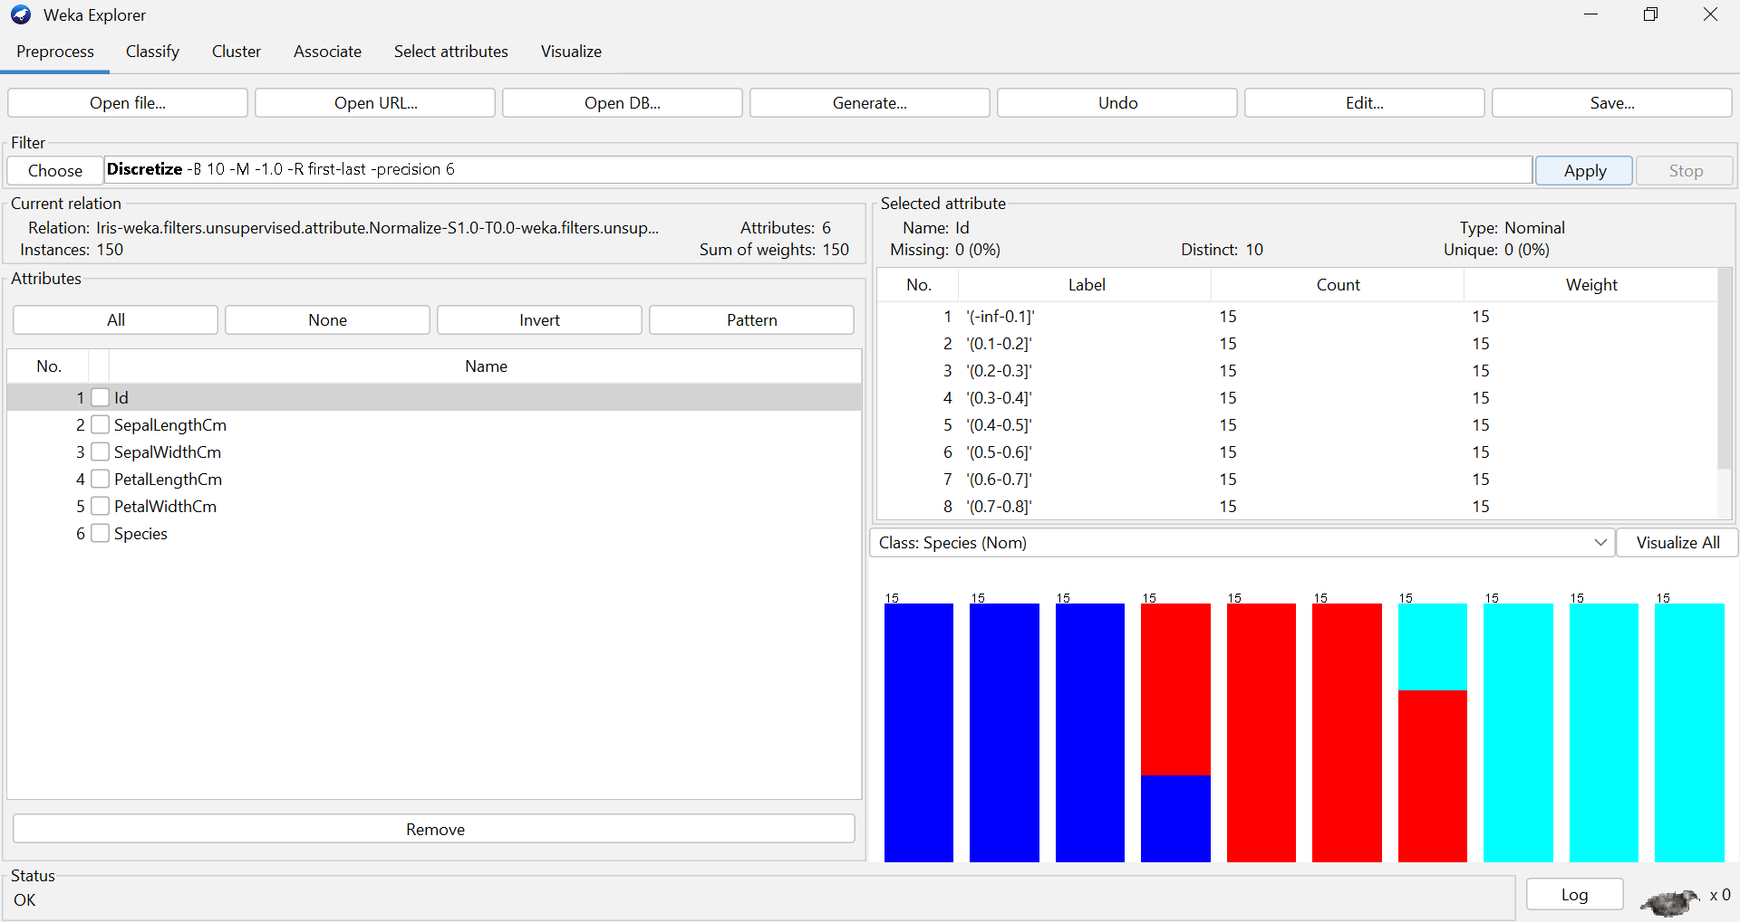



1. To plot a decision-tree go on to the “Classify tab”.
2. Click the “Choose” button and select “REPTree”, it us under tree -> REPTree and then select “Apply”. Click on the Start button and then visualise the tree by right clicking on the model.

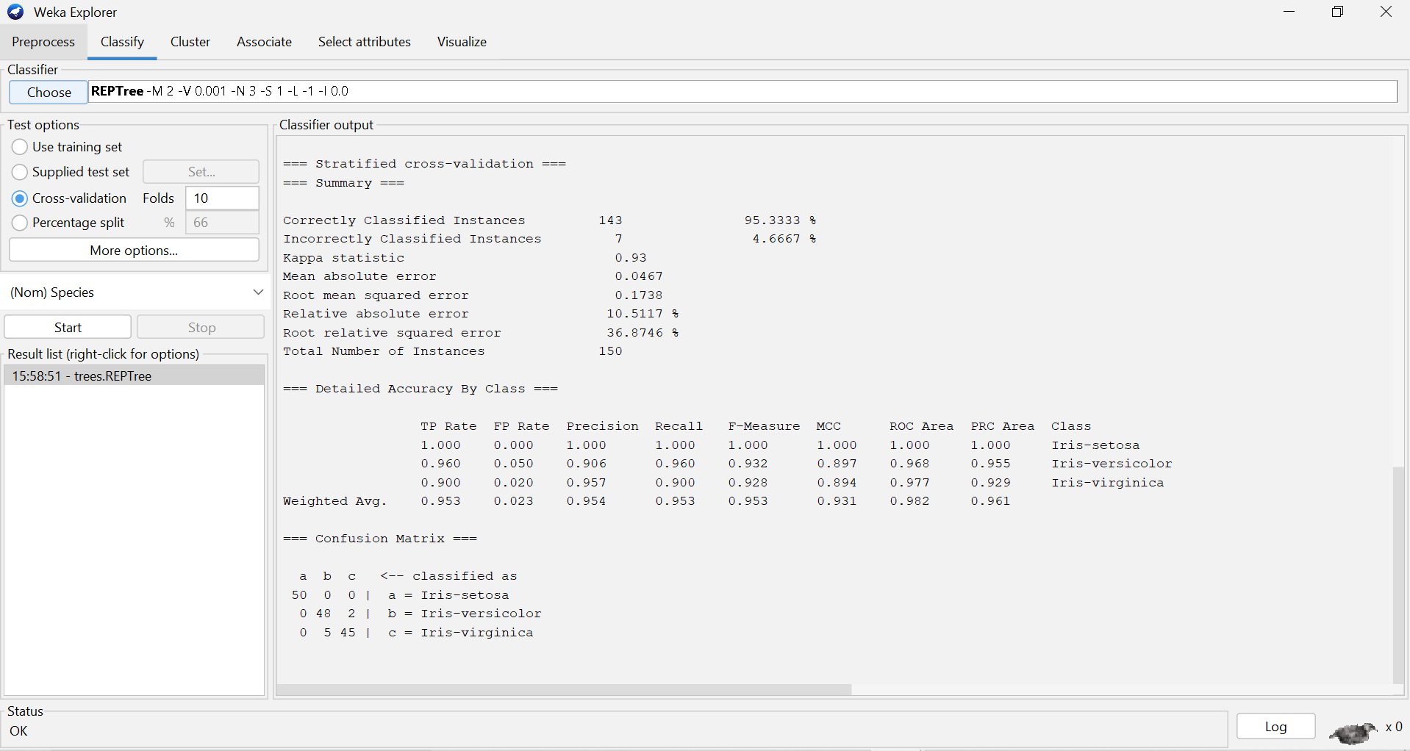



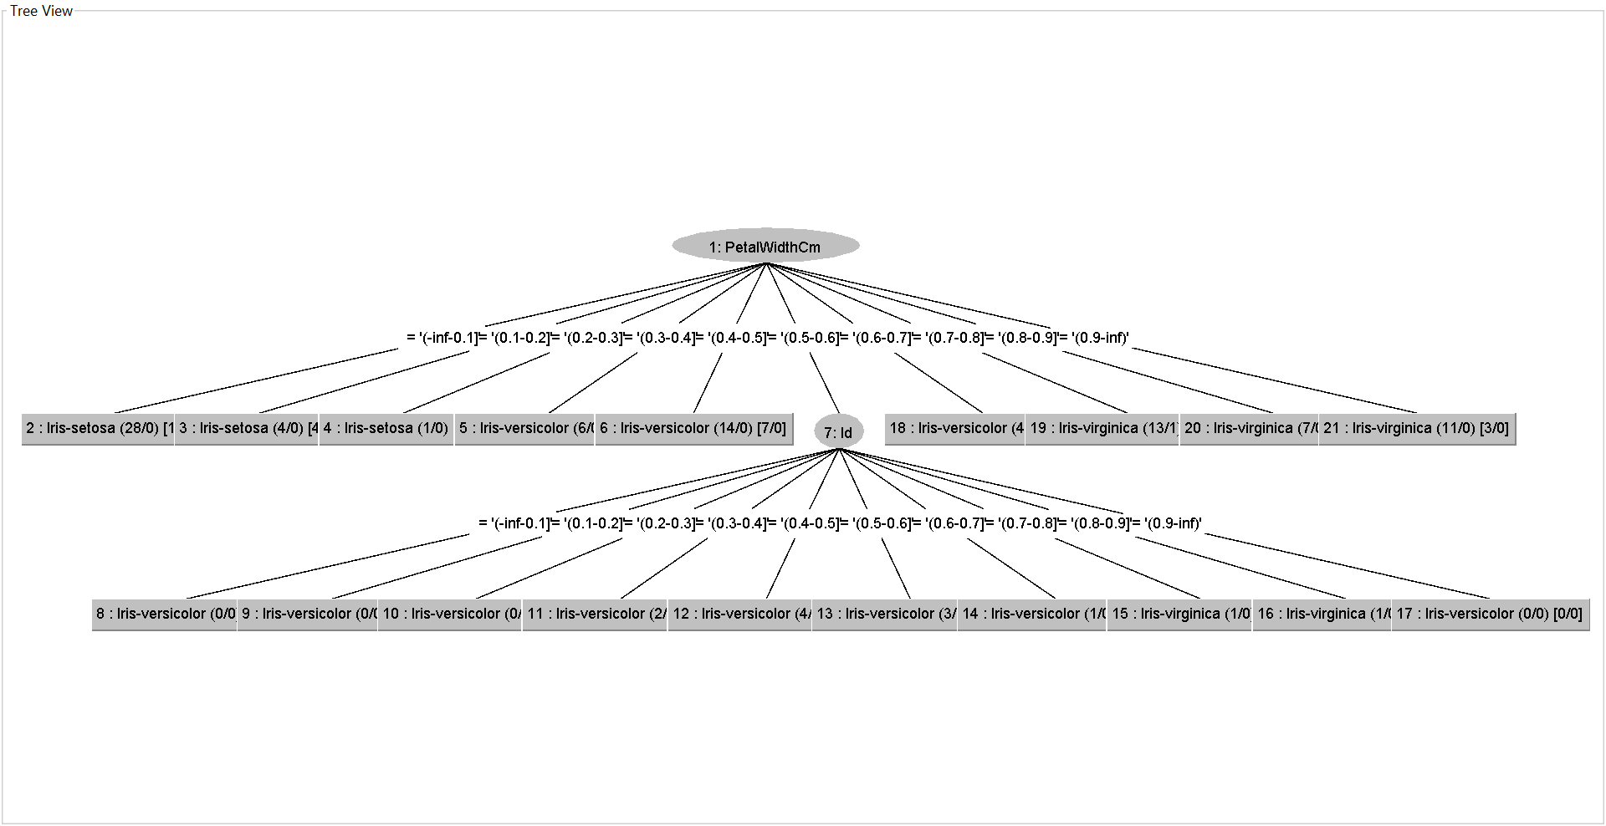

**EXPERIMENT-4**

**AIM:** Make a dataset of about 10 rows having various types of attributes (nominal, ordinal, interval, ratio), then calculate the dissimilarity matrix for it. You can implement this in any programming language of your choice.

**CODE AND OUTPUT:**

**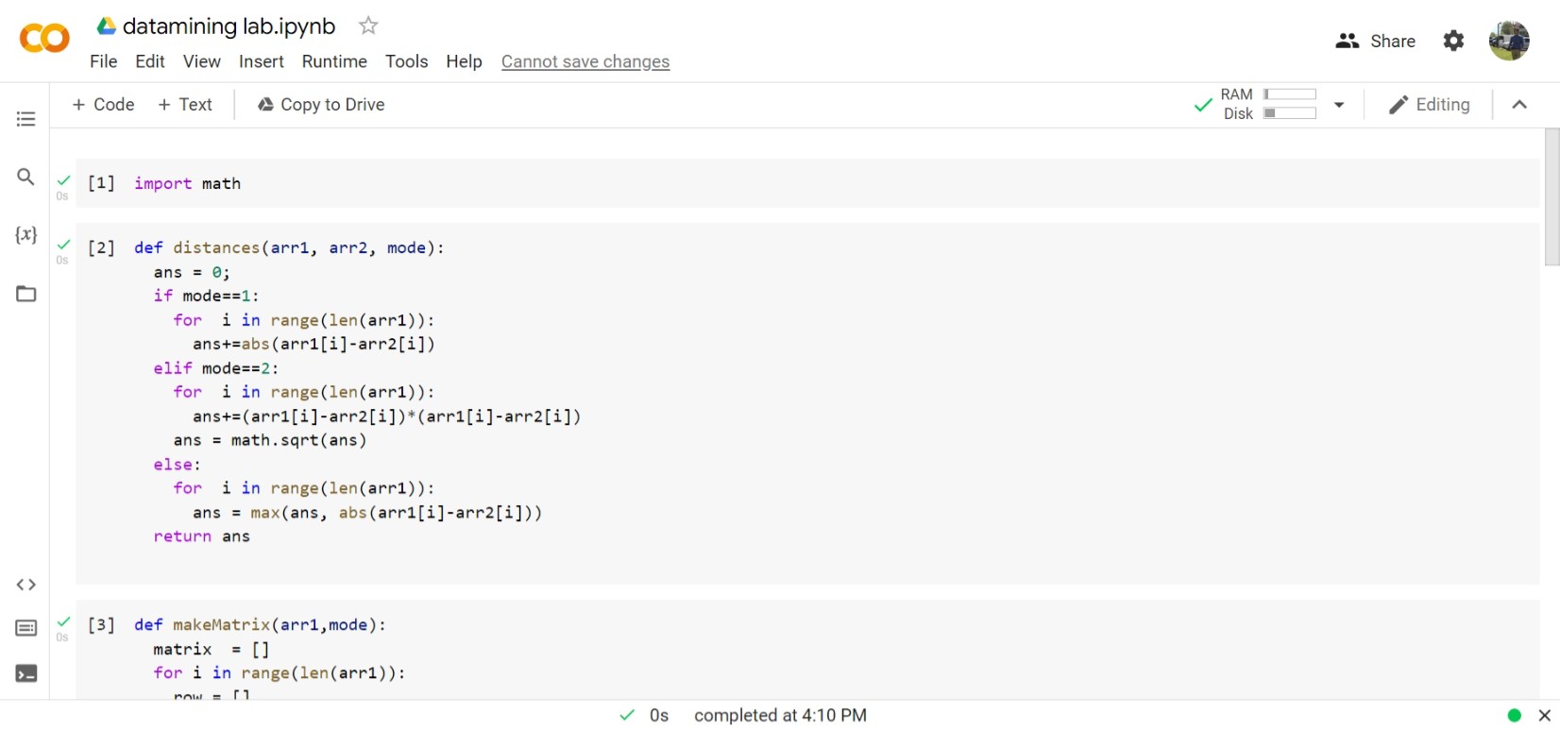  
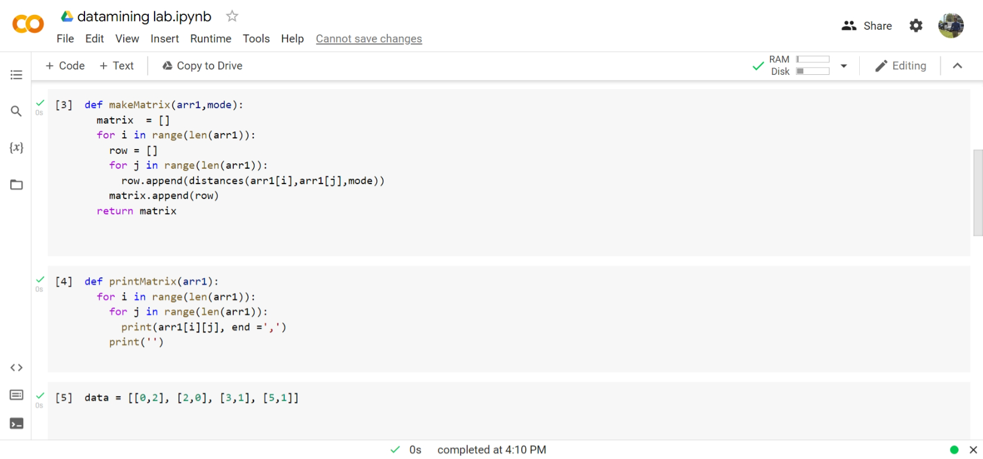**

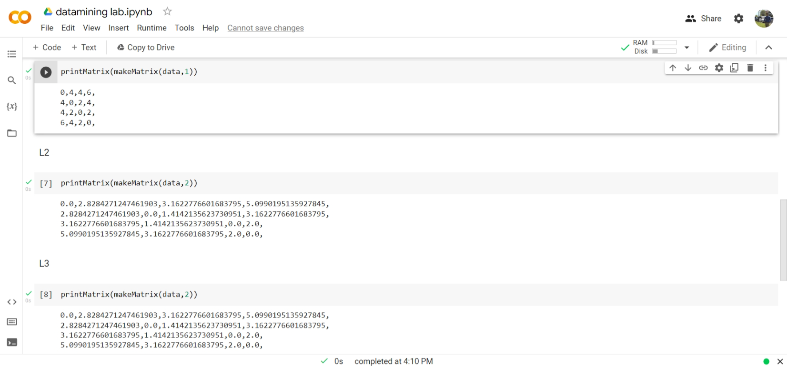

**EXPERIMENT-5**

**AIM:** Implement regression (linear, logistic, any one) in python on any dataset of your choice.

**CODE AND OUTPUT:**

**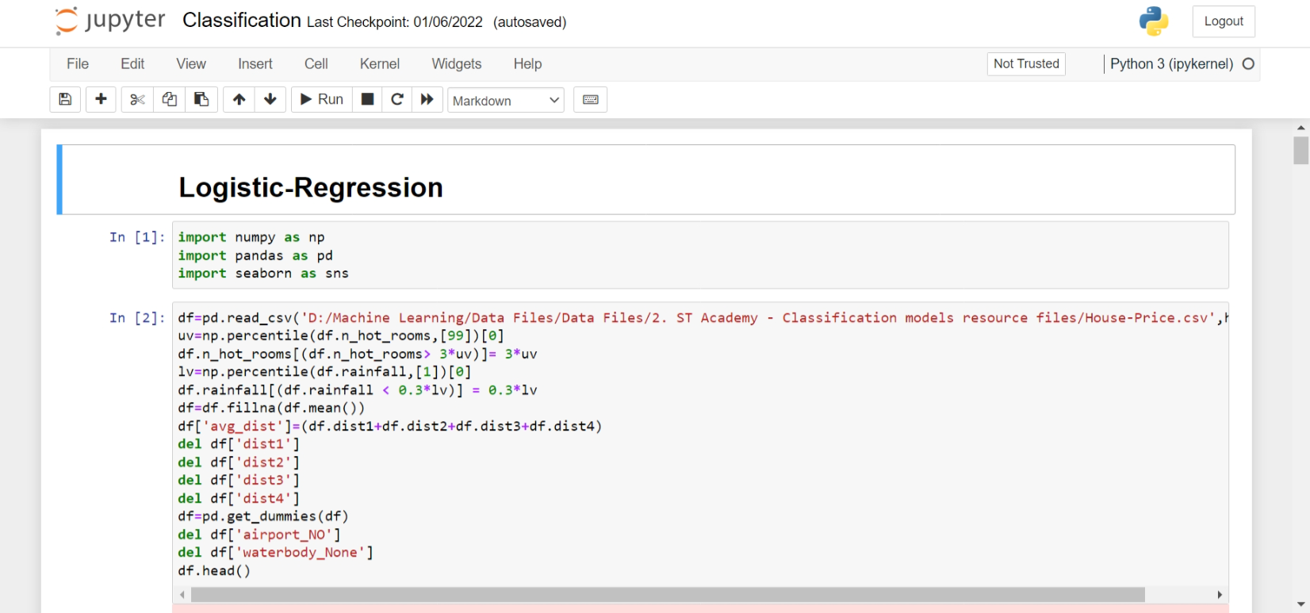  
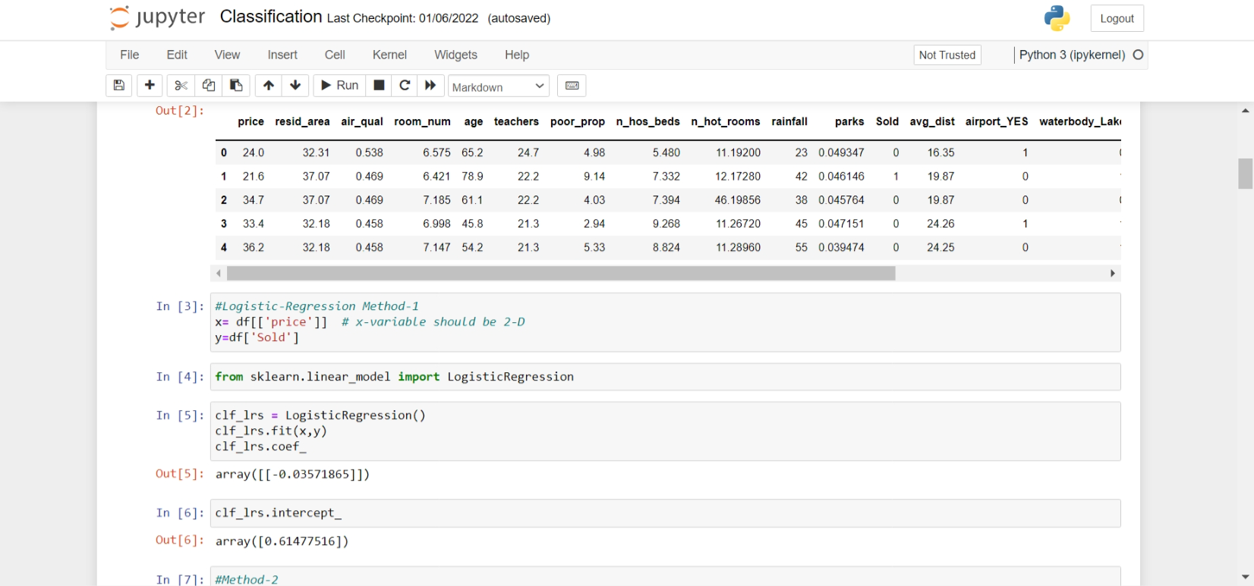  
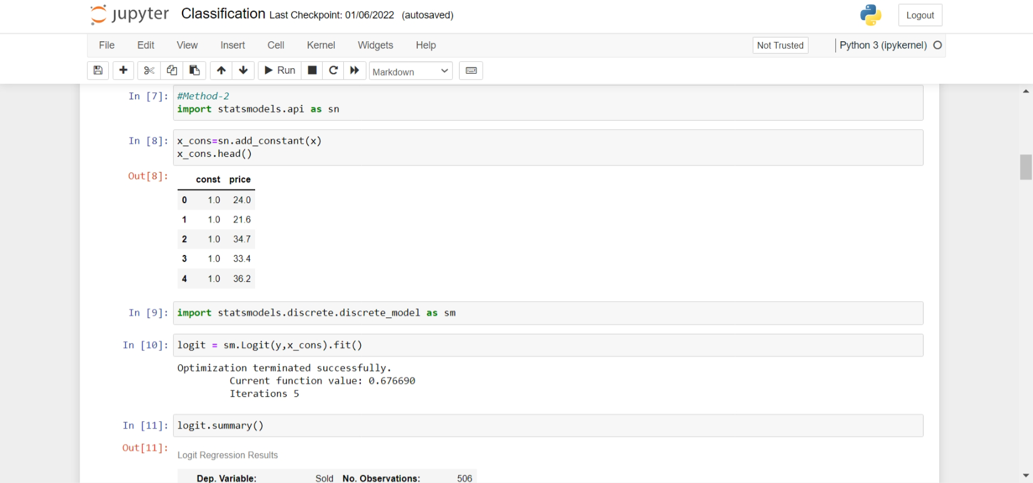  
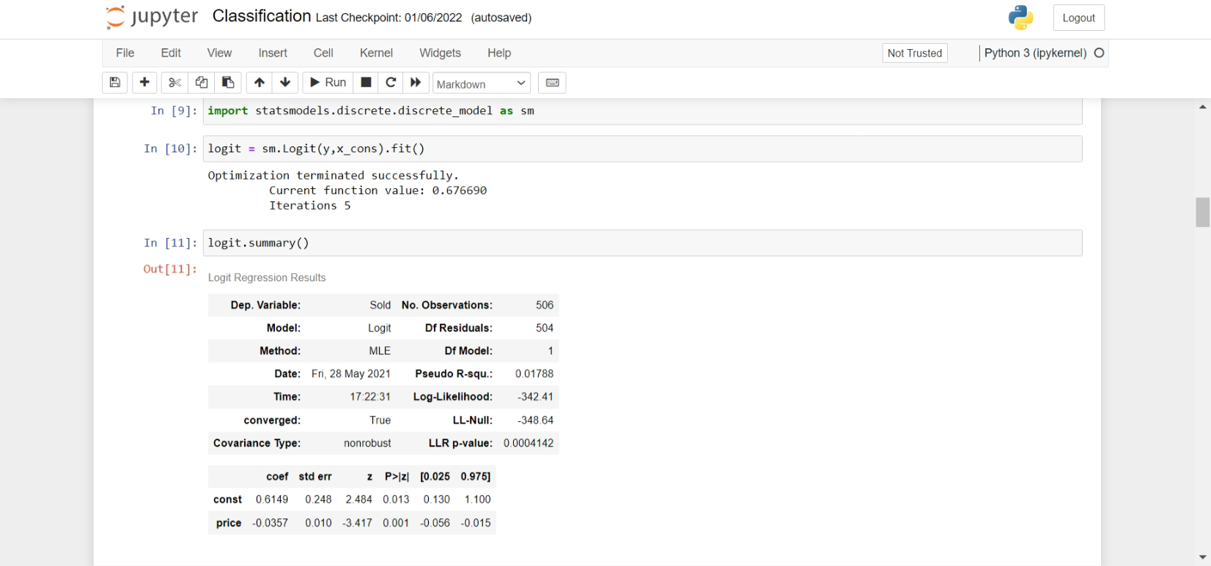**



**EXPERIMENT-6**

**AIM:** Implement KNN (K Nearest Neighbours) in python on any dataset of your choice.

**CODE AND OUTPUT:**

Dataset and pre-processing are same as in experiment-5.

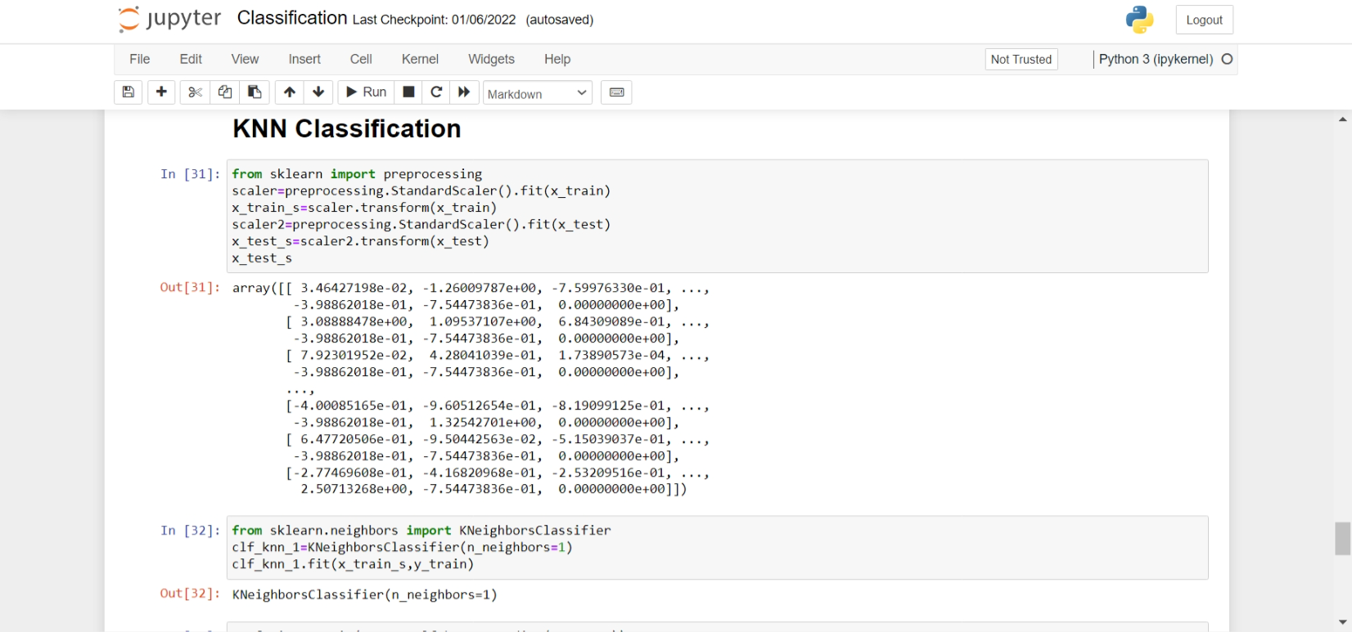  
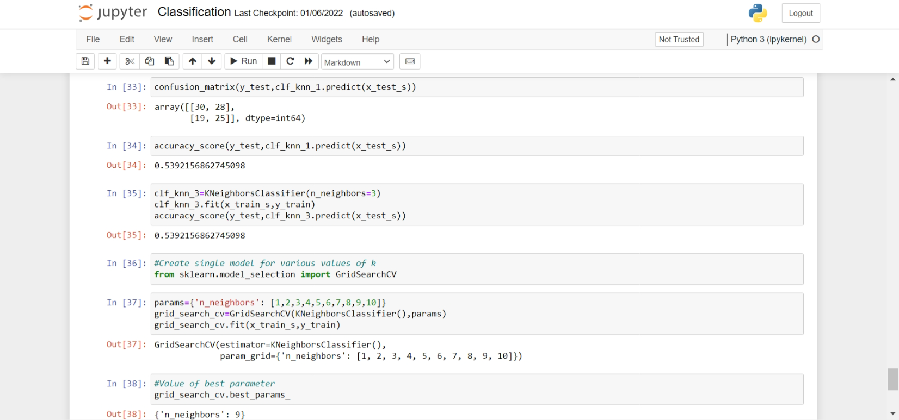  
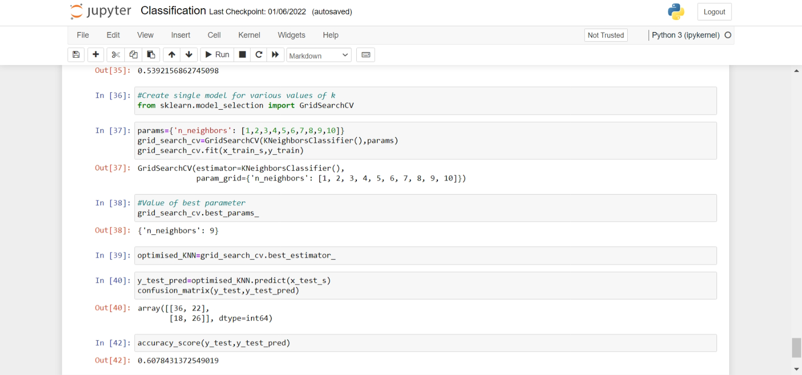



**EXPERIMENT-7**

**AIM:** Implement OneR algorithm in python on any dataset of your choice.

**CODE AND OUTPUT:**

**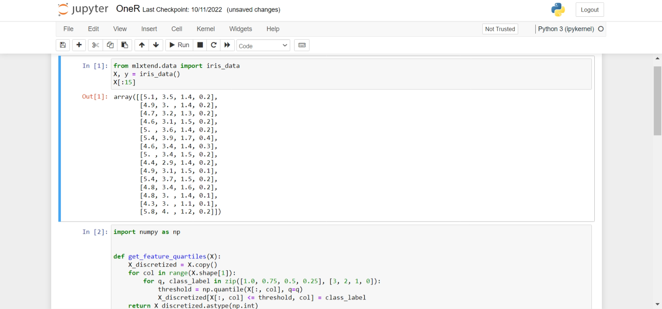  
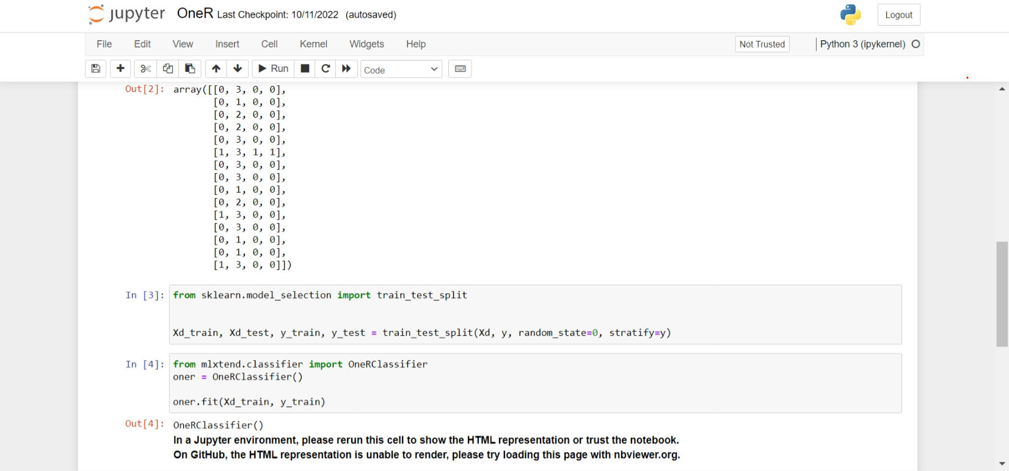**

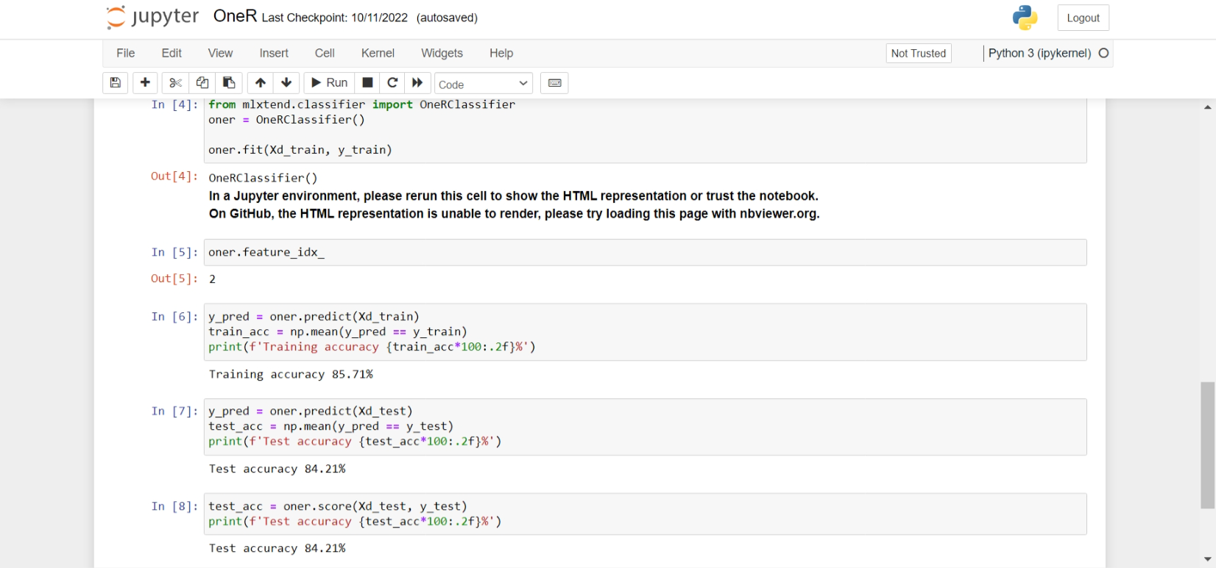



**EXPERIMENT-8**

**AIM:** Implement decision-tree and visualise it in python.

**CODE AND OUTPUT:**

**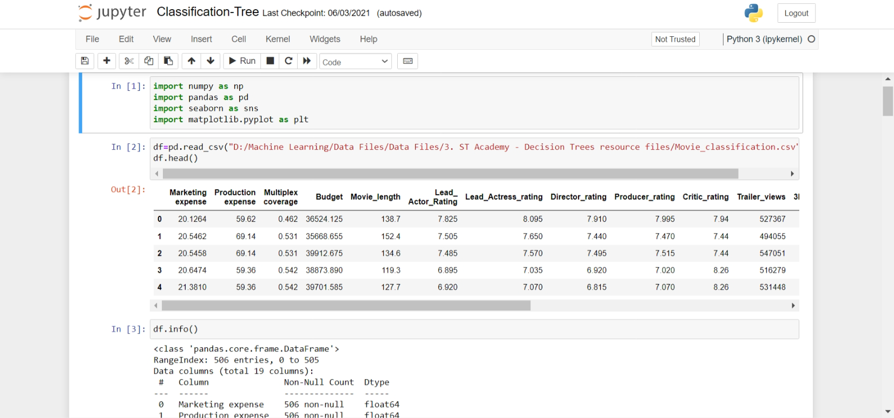  
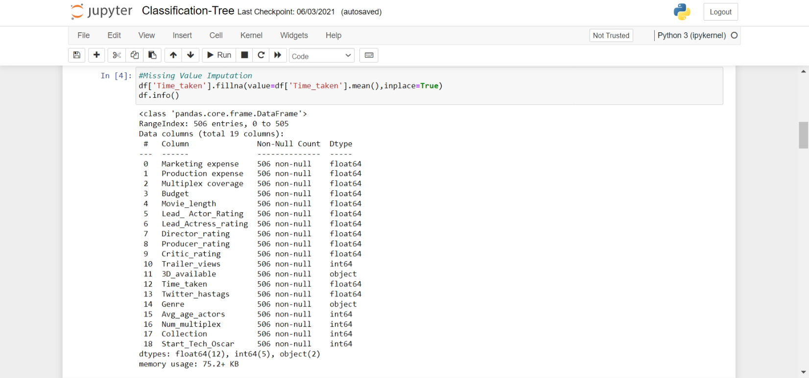**

**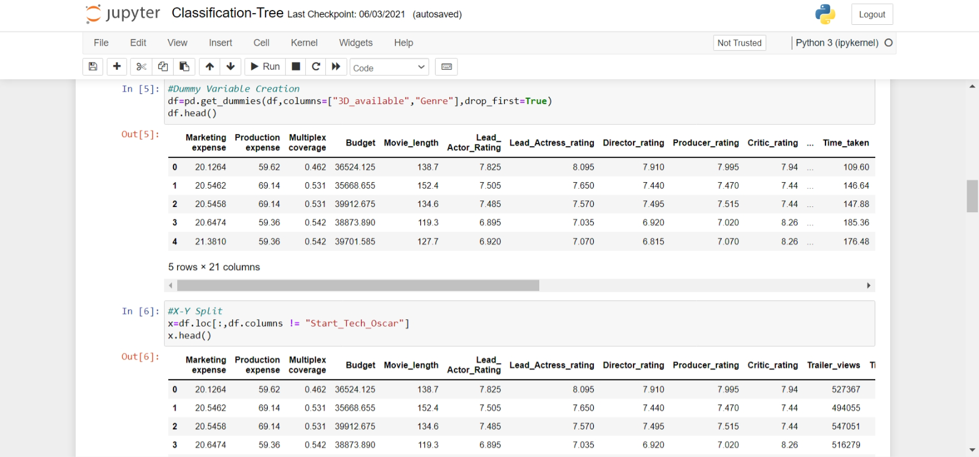  
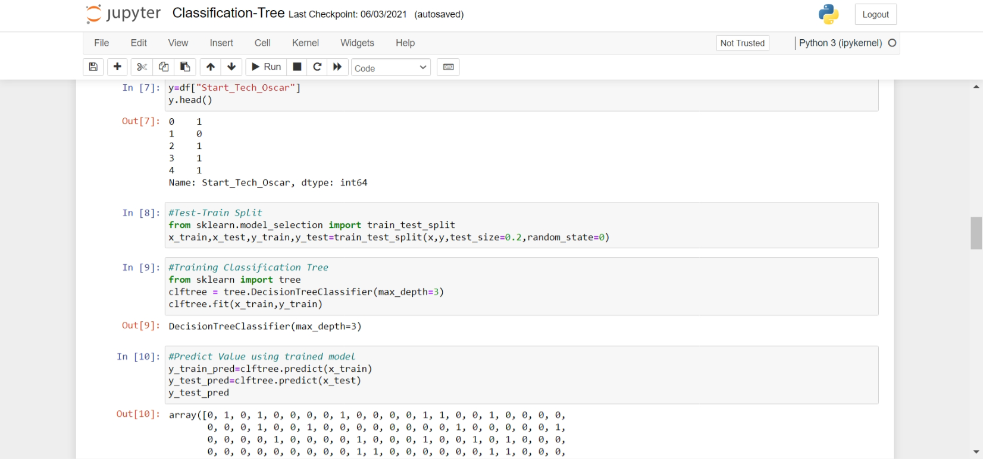  
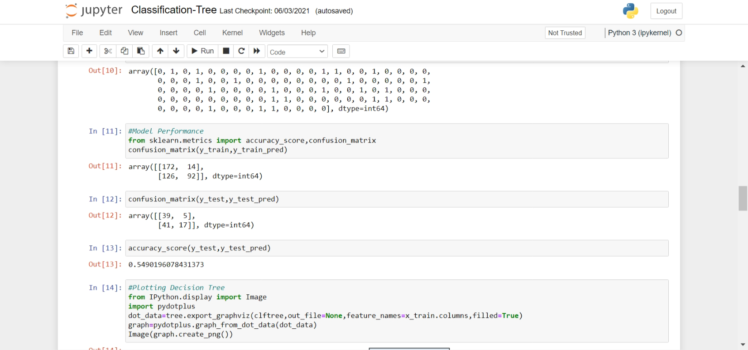**

**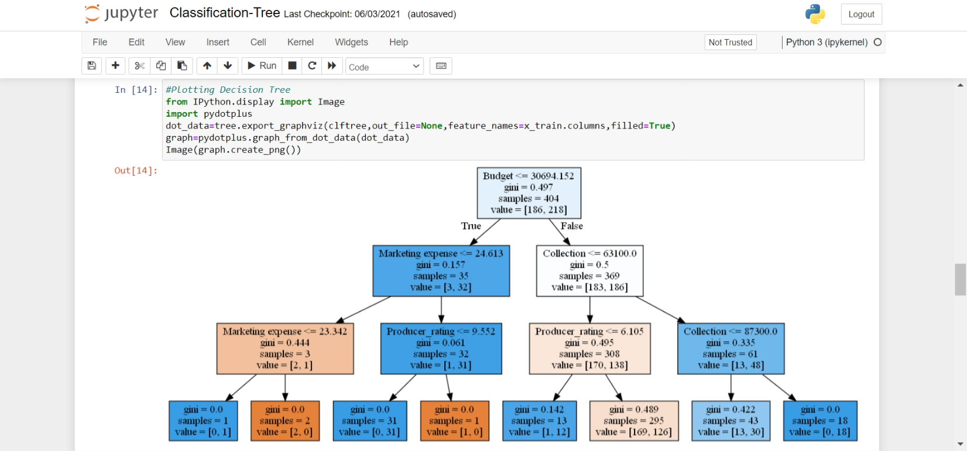  
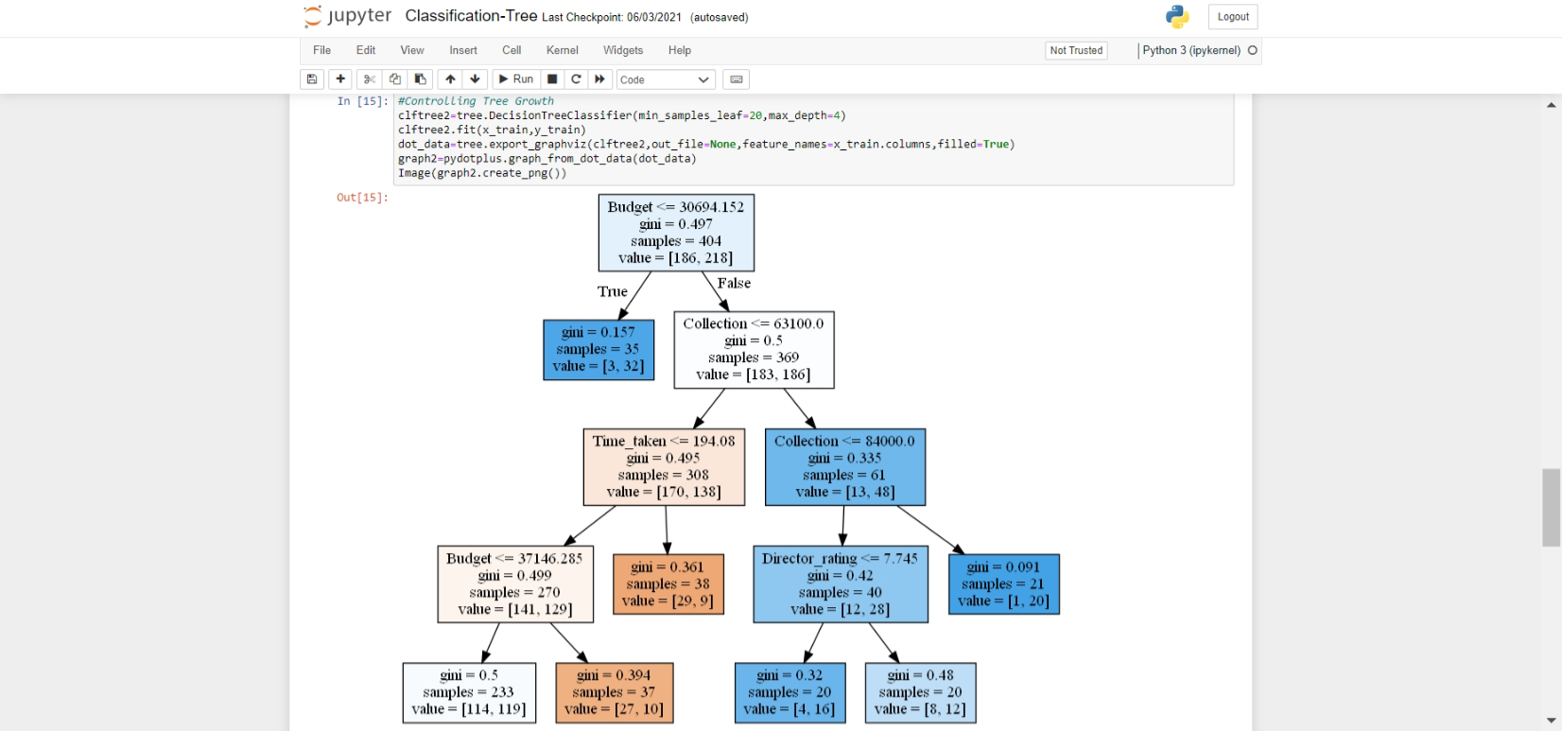  
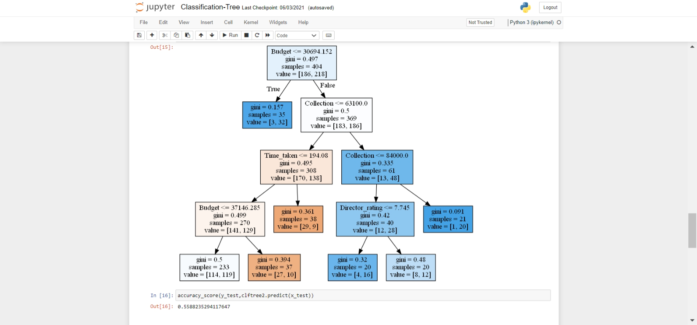**



**EXPERIMENT-9**

**AIM:** Implement Apriori algorithm in python.

**OUTPUT AND CODE:**

**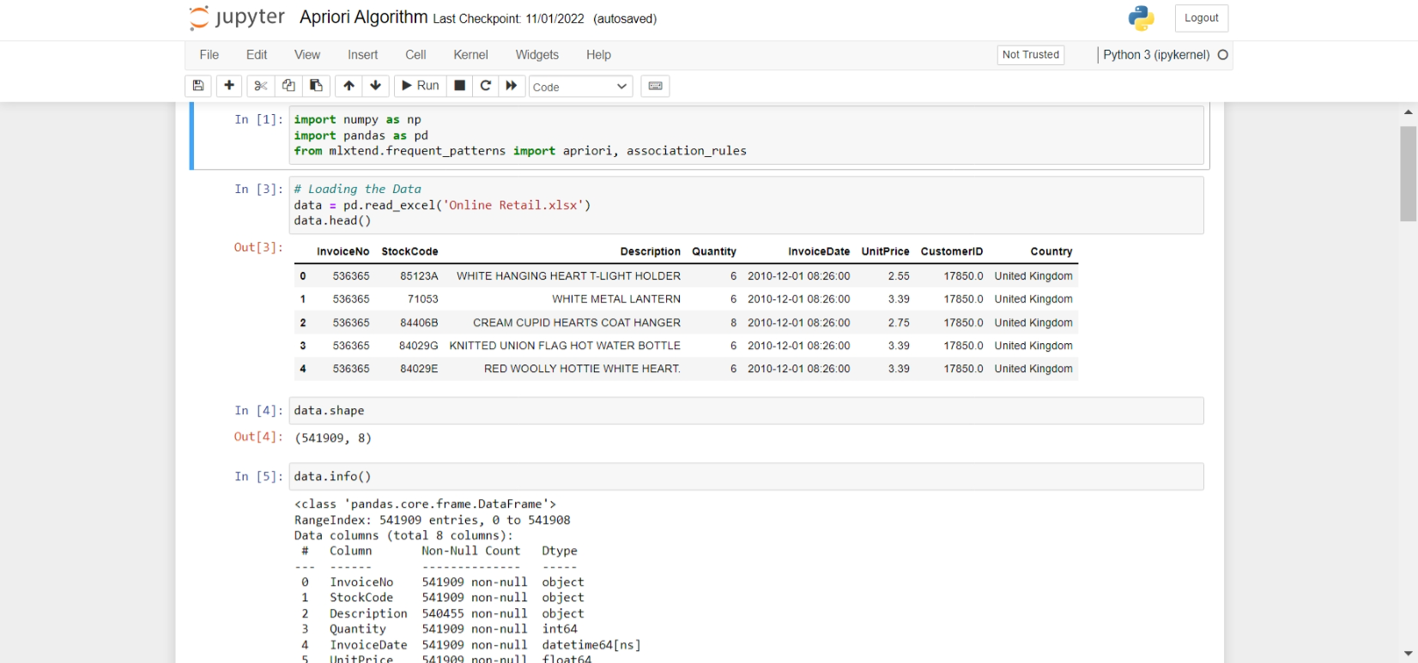  
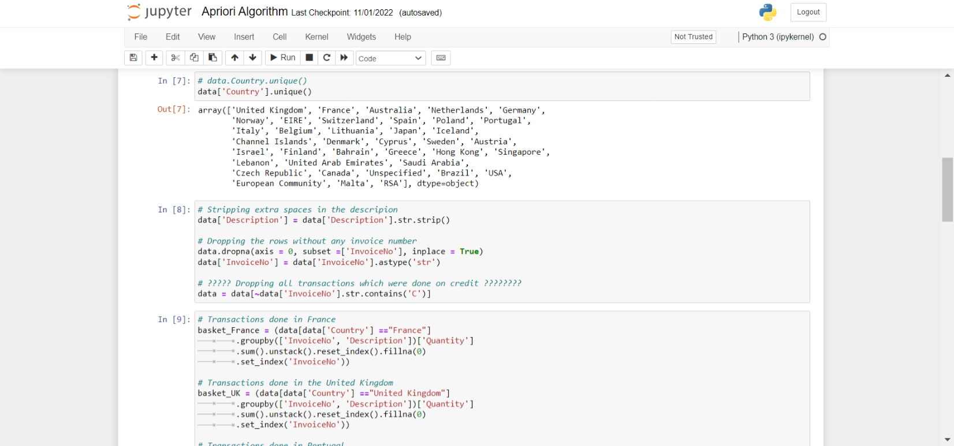**

**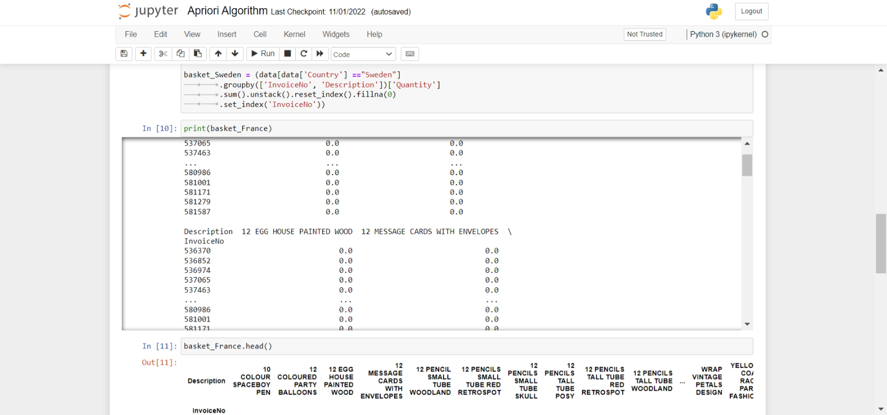  
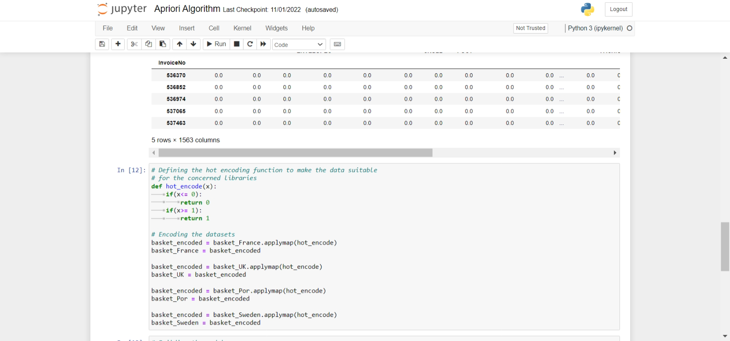  
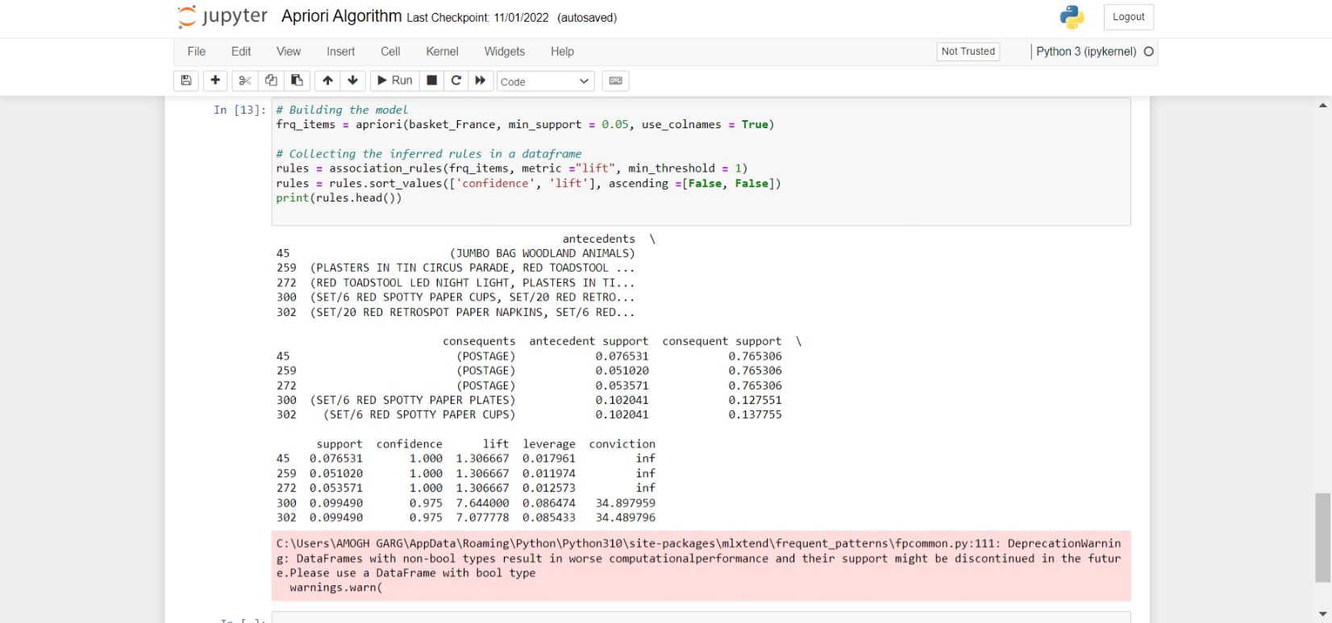**

**EXPERIMENT-10**

**AIM:** Implement FP Growth algorithm in python.

**CODE AND OUTPUT:**

**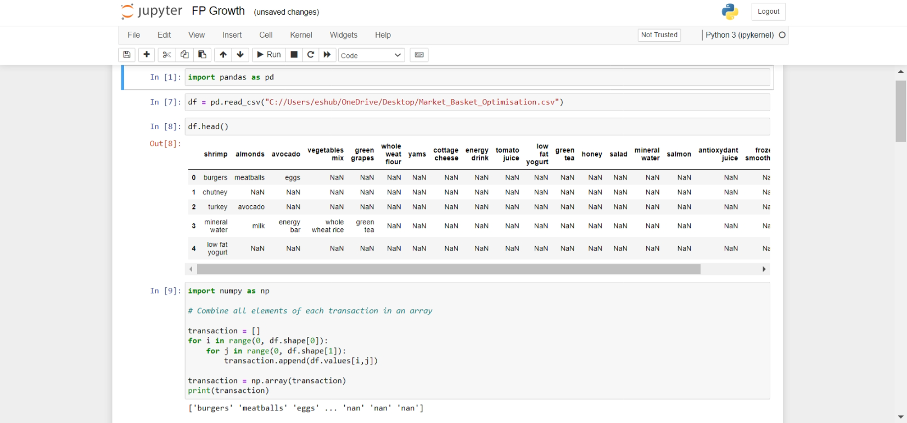  
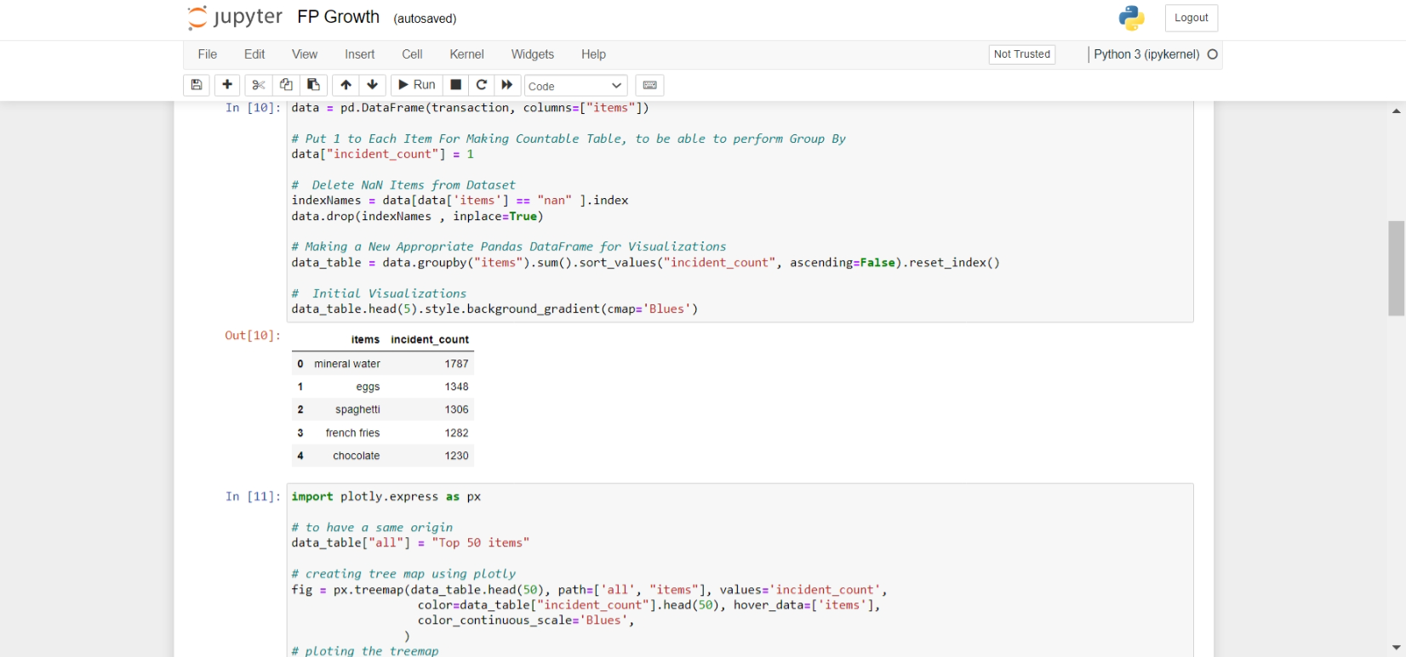**

**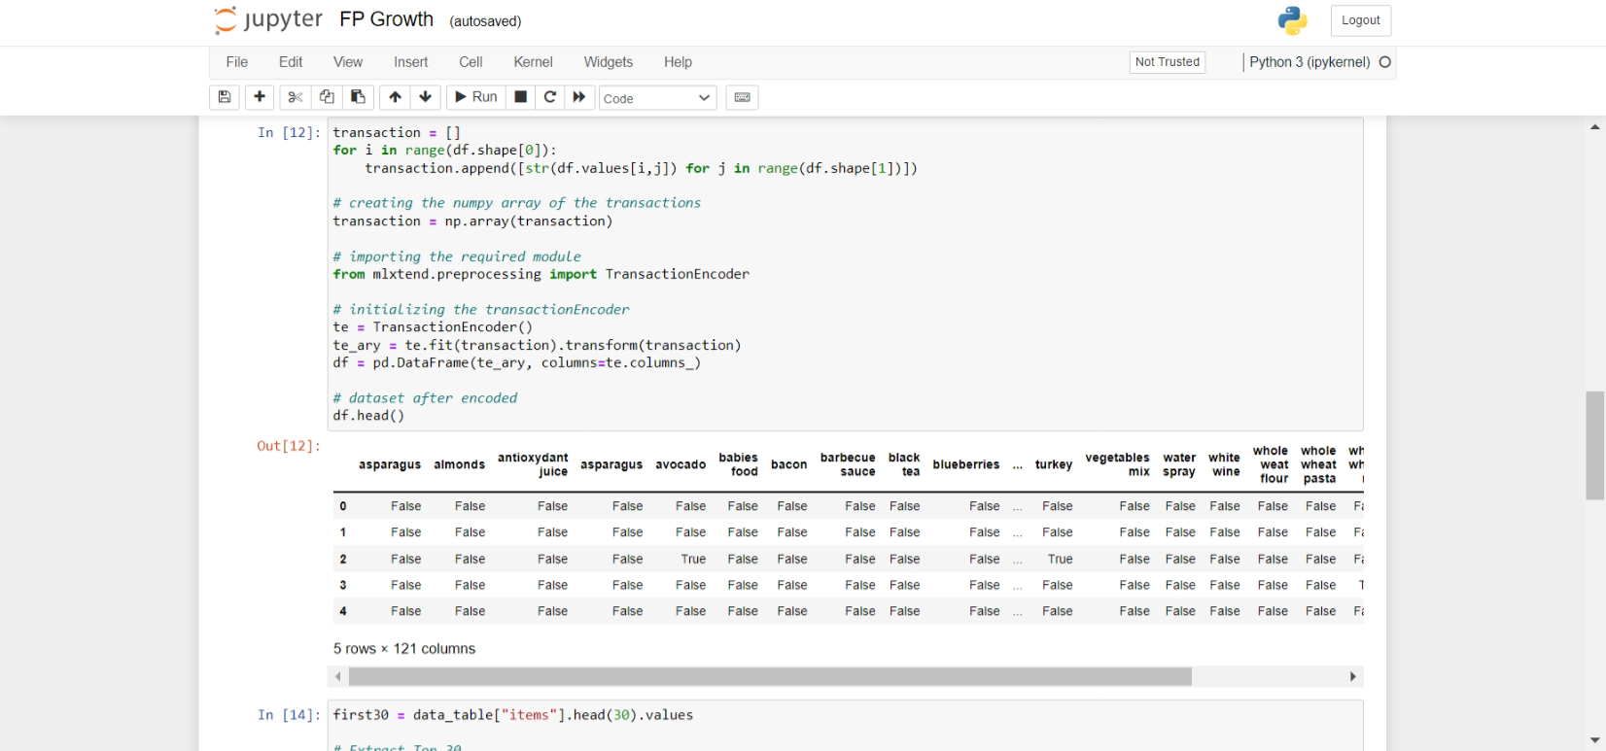  
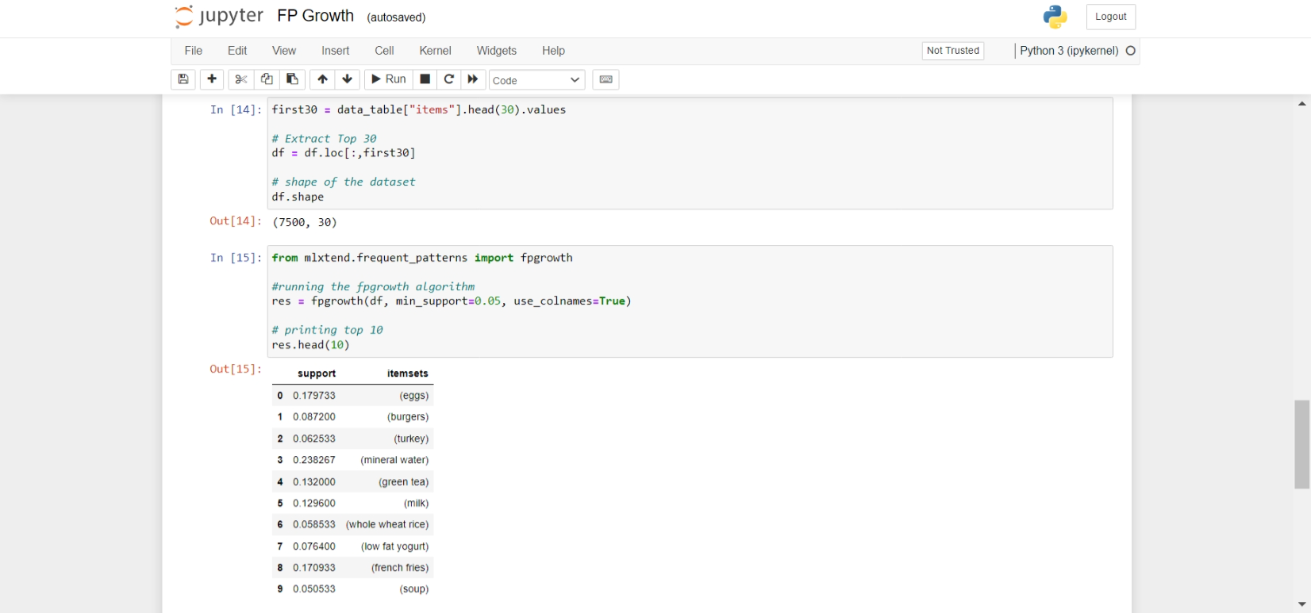  
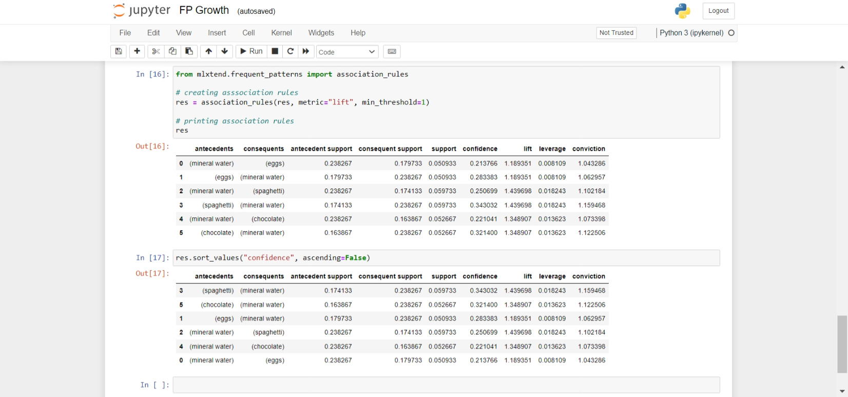**

**EXPERIMENT-11**

**AIM:** Implement Random Forest Classifier in python on any dataset.

**CODE AND OUTPUT:**

Dataset and pre-processing steps are same as in experiment-8(Decision-Tree).

